

History of Amahi
Chapter 1 Installing fedora 10 and Amahi Home Digital Assistant (HDA)
Chapter 2 Advanced Hard drive Partitioning
Chapter 3 YOUR DHCP/DNS OPTIONS
Chapter 4 Network Troubleshooting
Chapter 5 Getting Started

History of Amahi
Amahi started, like many open source projects, as an "itch" that had to be scratched. Having a server at home, for a Linux geek, seemed to be a logical way to centralize things. With the versatility of open source and they wealth of applications that can be run on it, the idea evolved into making a home server that could do more that just share files. Friends liked it and more and more people in the community recommended it, making it into what Amahi is
today!
It was clear that making it easily usable by the rest of the people in the family was important to its acceptance. From movies to music, to home documents and backups, the multi-purpose nature of the server emerged as key to its practicality, hence we devised. Making it easy to setup (within one hour instead of within one week otherwise), making it usable by the
rest of the home network and making it modular with applications that could be easily installed was then the goal the community set for Amahi.

CHAPTER 1
Installing fedora 10 and Amahi Home Digital Assistant (HDA)

Insert you fedora 10 DVD.
A couple of things you are going to need:
- A computer with the minimum specifications of:
    - 800MHz CPU
    - 4GB Disk
    - 512MB RAM
    - But more is better :)
- A bootable Fedora 10 installation DVD
- A Internet connection to the computer during installation.
- A install code from www.amahi.org

You will want to start the computer and put the DVD in the DVD drive, the screen my prompt you to boot from CD/DVD.

The first screen you will want to click “next”, this next screen you will need to select you language and click “next”, this screen you will need to select you keyboard layout and click “next”. On this screen you will want to choose “Install Fedora” and click next.

On this screen make sure your “Network Device” is checked “Active on boot”, your Host name should be set to “automatically via DHCP”, and leave “Miscellaneous Settings” blank and click “next”.

Now select your time zone and click “next”.

Setup your root (Admin) password, be sure not to forget this and click “next”.

This screen should be left as default (Remove Linux partitions on selected drives and create default layout) unless you are an advanced user (Note for advanced users: /var/hda/files should be the largest partition) and click “next”. See “ADVANCED HARDDRIVE PARTITIONING” for an example of how to set up your hda

As long as you partitioned to the default settings, then you can leave the boot loader set to default also and click “next”.

This step is to set up the Home Digital Assistant (HDA) repositories, you will want to de-select “Office and Productivity”, unless you are going to use you HDA home server as a desk top also, which we advise against.
Now we will click on “Add additional software repositories”, and screen will pop up called “Enable network interface”, leave as default and click “ok”, the next pop up you will add under Repository name “Amahi”, under Repository URL: http://f10.amahi.org, click “ok” then “next” on the original screen.

The system will now install the base OS; this will take a little time. Now is the perfect time to go check out the application we have at http://www.amahi.org/apps

Once fedora as completed installation you will be asked to reboot.

After the reboot you will come to the welcome screen click “Forward”, next is the user license information, read if you choose and click “Forward”.

Now you will be asked to create a user, at this time I want you to skip this step and click “Forward”, a pop up will say it is recommended but just click “continue” anyways.

In the Date and Time screen, click on the “network Time Protocol” tab, click the box net to “Enable Network Time Protocol” and click “Forward”

On the Hardware Profile page, its asking you to send hardware information about your pc to fedora to help better improve the software, its up to you to send it or not and then click “Finish”

Now it is time to login, you will want to use the user name and password that you created earlier in the process. Note: You can not log in as root.

Note: Ignore the security updates at this time; they can not be installed at this time.

To do that, in the upper left corner click application, system tools and then terminal.

Using the code that you created in the control panel at www.amahi.org, type sudo hda-install “yourcode”, you will be prompted for your password, enter it at this time.

After the install completes you will be asked to reboot and turn off your router's DHCP server and renew network connection on your "client" machines.

And that's about it; I hope this helped make your installation go smoothly.

CHAPTER 2
ADVANCED HARDDRIVE PARTITIONING

Instead of using the default you can go with an advanced partitioning schema.
I will use my system as an example; I am using a 60GB hard drive for fedora and a 1TB for hda part of the system.
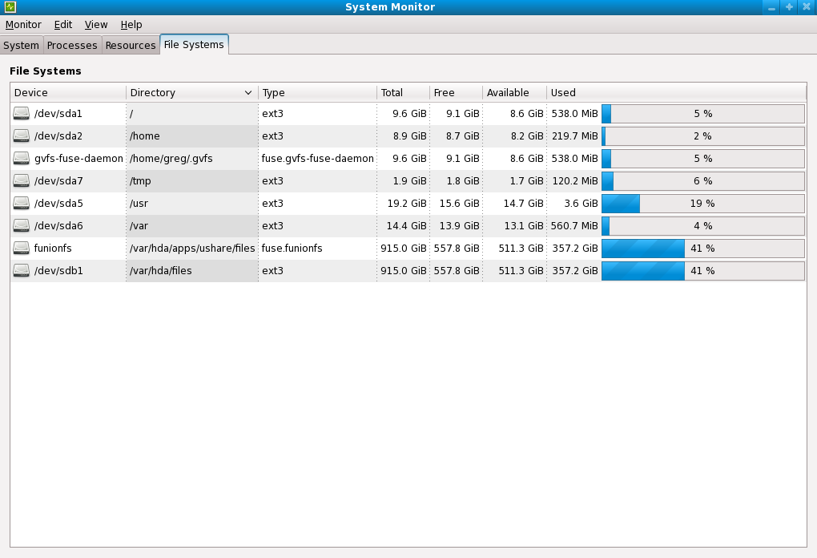

Choose “Create custom layout” and click “Next”
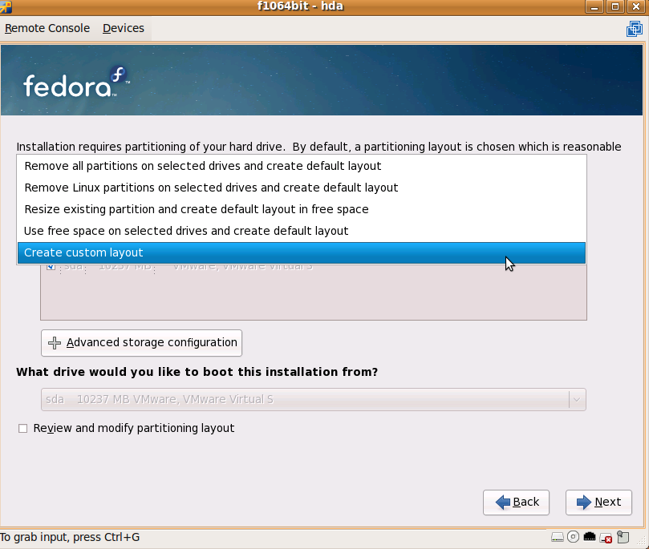

Enter the size you would like your user home accounts, this can be low as hda does not use the home partition.
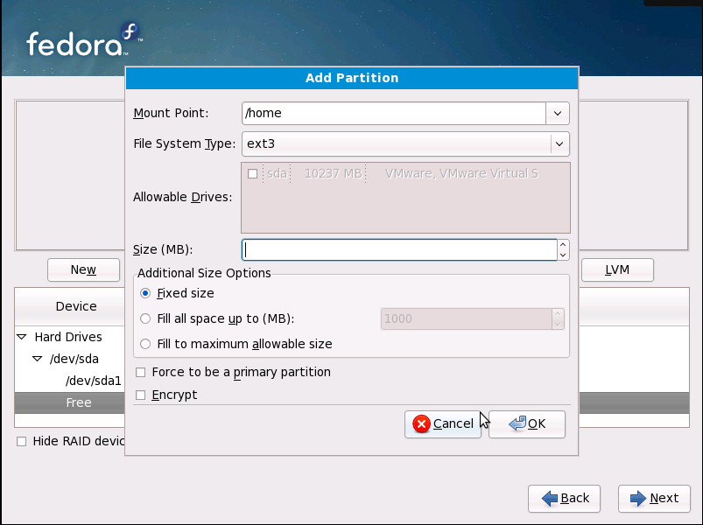

Fedora I believe requires 2.5 GB at a minimum for / (root) I
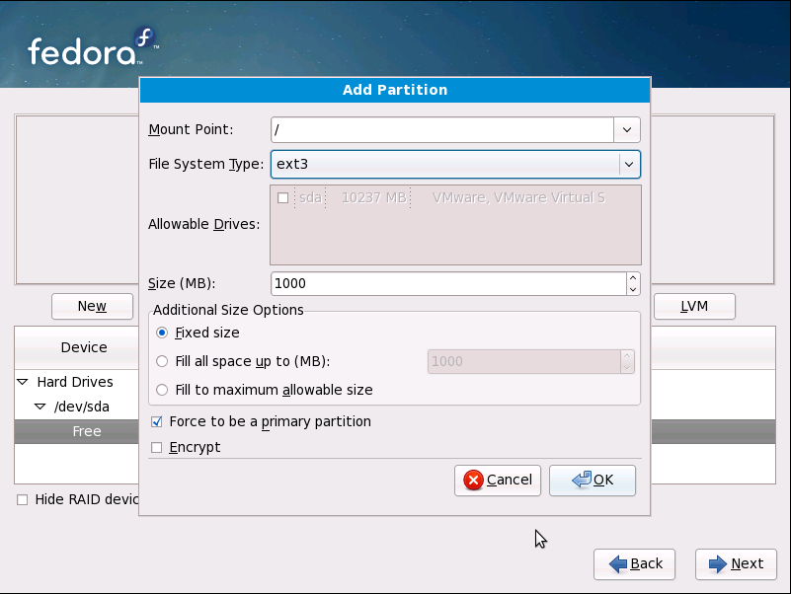

For swap, the rule use to be 1 ½ to 2 times the system RAM, now I do about 1 GB to 2 GB.
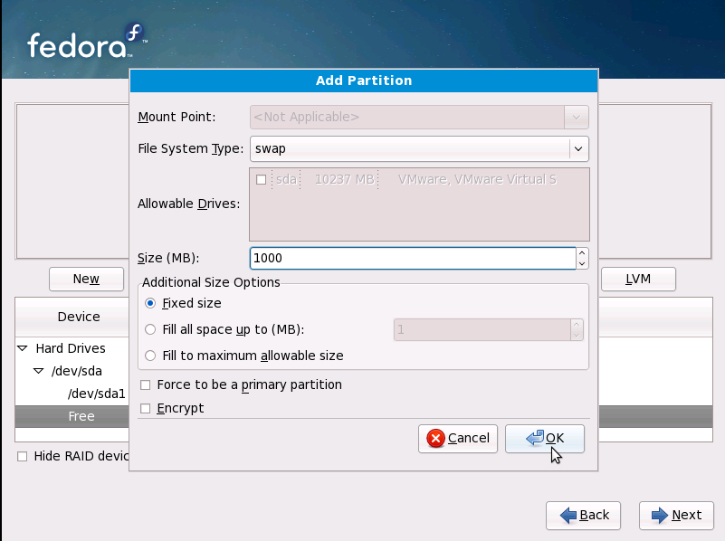
Can't forget about /tmp, sorry no screen shot, I usually use about 2 GB.

For /usr you will want this to be pretty big, I would say at least 10 GB
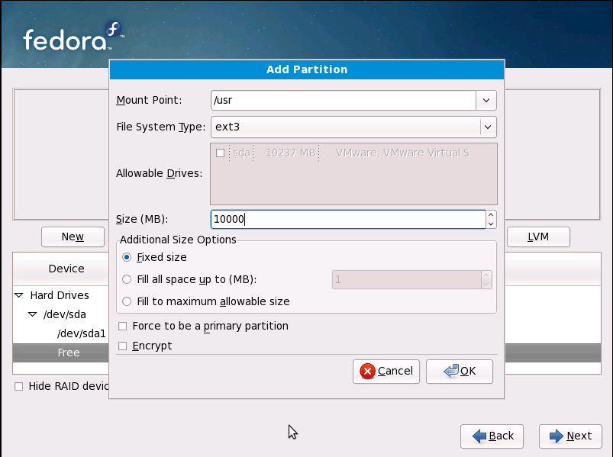

For /var, this can be some what low, I did 14 GB and am only using 4%
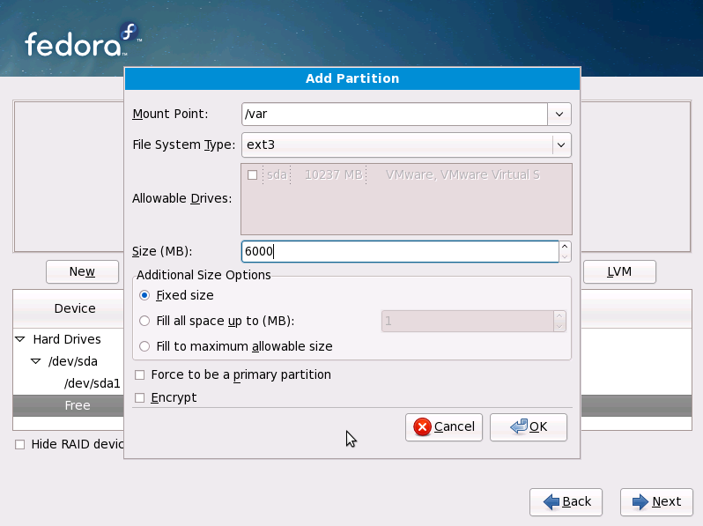

For the hda partition, I used my 1TB /var/hda/files; this is where all the share drives are such as music, Doc, Pictures etc....

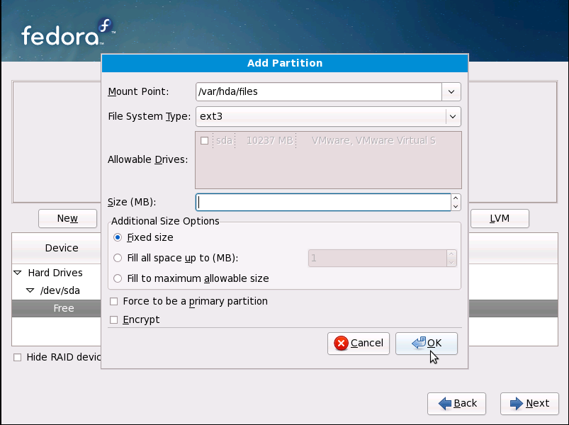

CHAPTER 3
YOUR DHCP/DNS OPTIONS

You can optionally turn off your router's DHCP server for your LAN and let the Amahi HDA give out the DHCP leases for the systems in your network. Some people are understandably hesitant to do this, so we made it optional.
Many hundreds of people use the Amahi HDA as their DHCP and caching DNS server 24x7, so we believe it's reliable for continuous use.
You have several options:
- Use your HDA's DHCP and caching DNS server: This is the recommended configuration to have the all the features of the apps that come with Amahi.

- Use only your HDA's caching DNS server: To do this, change the DNS that your router gives out in the DHCP requests (or change your clients) to your HDA's IP address. By pointing your router DNS to the IP address of the Amahi HDA you will get a lot of the functionality all of the machines in your network that use it. With this setup, everything will work, except:
  - Assigning of static IPs in your network settings will not work
  - PBA (Personal backup assistant) will work, except you will not be able to network boot your systems. Use the SystemRescueCD boot option.
  - Automatic DHCP naming of machines in your network will not work (the Amahi DHCP is configured to automatically allocate DNS names for machines that request their name via DHCP).
  - Your Amahi HDA-provided domain will not work inside your own network
- No change in DHCP or DNS in your router: You can use the desktop in your HDA and do most every feature on your Amahi HDA, as the HDA will use its own DNS server. Other machines in the network will not take advantage of most features in the Amahi HDA. They will probably see the file server in the HDA, though it may only be accessible with an IP address, not a name. The AmahiTunes server and UPnP server may be visible to clients; however, this is not tested nor supported.

CHAPTER 4

Network Troubleshooting

Rule #1: do not turn off DHCP in your router until your HDA has full network connectivity
Your HDA should be capable of browsing all the major sites and http://www.amahi.org before doing anything else upon first boot.
If that is not the case, you may want to check that the settings that you programmed in amahi.org for your network and router match that of your actual network and the router in it. Amahi assumes a regular, typical home network.
Steps in network troubleshooting:

Step 1
From your hda itself (via ssh or at the desktop in a terminal), can you:
- ping hda (this ensures the DNS server is working)
- ping router (this ensures your HDA can see the router)
- ping 68.180.206.184 (this ensures you can see the rest of the world)
- ping yahoo.com (this ensures your DNS server can see the world)
If the above does not work, try and fix it by double checking the settings.

Step 2
If the above works, then and only then you may turn off the DHCP server in your router.
'IMPORTANT: after turning off the DHCP server, you must repair (or reboot) your clients for them to get the DHCP lease from your Amahi HDA.
Then move to one or more the clients:
- ping hda (this ensures the client can see the DNS server in your HDA)
- ping router (this ensures the client can see your network gateway)
- ping yahoo.com (this ensures the client can see the world)
If you want to stop by the IRC channel for help, it would speed things up to report where you are "stuck" in that list, like step 1.3, or 2.2.

CHAPTER 5
GETTING STARTED

OK. You've just finished installing your Amahi Home Server and rebooted it (we call it an HDA - Home Digital Assistant for short). Now what do you do?
Well, the first thing is to connect to your HDA from a computer on your network. Simply enter hda (http://hda) in the URL for your browser and you'll find yourself looking at your HDA home page (you may need to refresh your network settings since your HDA is now managing your network).

To get going we recommend the first things you do are:
- Create a user to access shares
- Create a share for storing/sharing files in your network

Create A User
To create a user
- use the setup link (http://setup)
- select the Users tab
- press the "New User" button
- enter information for the user and press the "Create button"

Create A Share
To create a share
- use the setup link (http://setup)
- select the Shares tab
- press the "New Share" button
- enter information for the share and press the "Create button"
Once a share is created you can specify more details about it. Click on the Share you just created and you can specify
- whether it is visible to users on your network
- which specific users can access (read) or write to the share
- what sort of information will be stored in the share

Doing More with Your HDA
Return to http://hda where you will find links to
- Setup - where you can setup your HDA (http://setup)
- My Apps - install/uninstall additional HDA_Apps
- Wiki - create and edit your personal Wiki
- Calendars - shared calendars for everyone in your house
Of course there are a whole lot of other things you can do with your HDA (like use the VPN to have secure remote access, publish multiple calendars, etc).

